Day 2 SQL question set answers

Harsh Morayya
21WU0101056

To refer to the questions, cross-reference with Material/SQL-questions-set1-final.pdf

Q1.
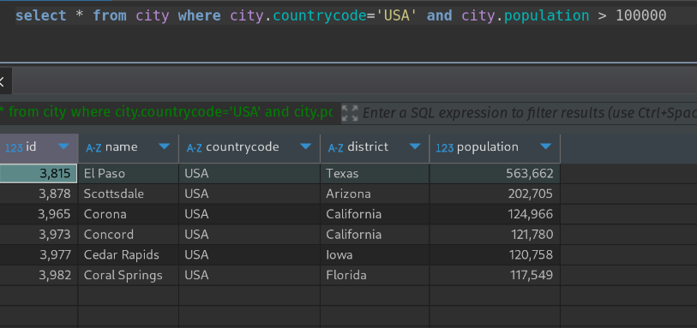
Q2.
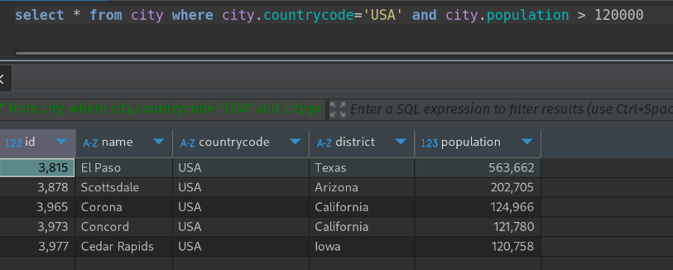
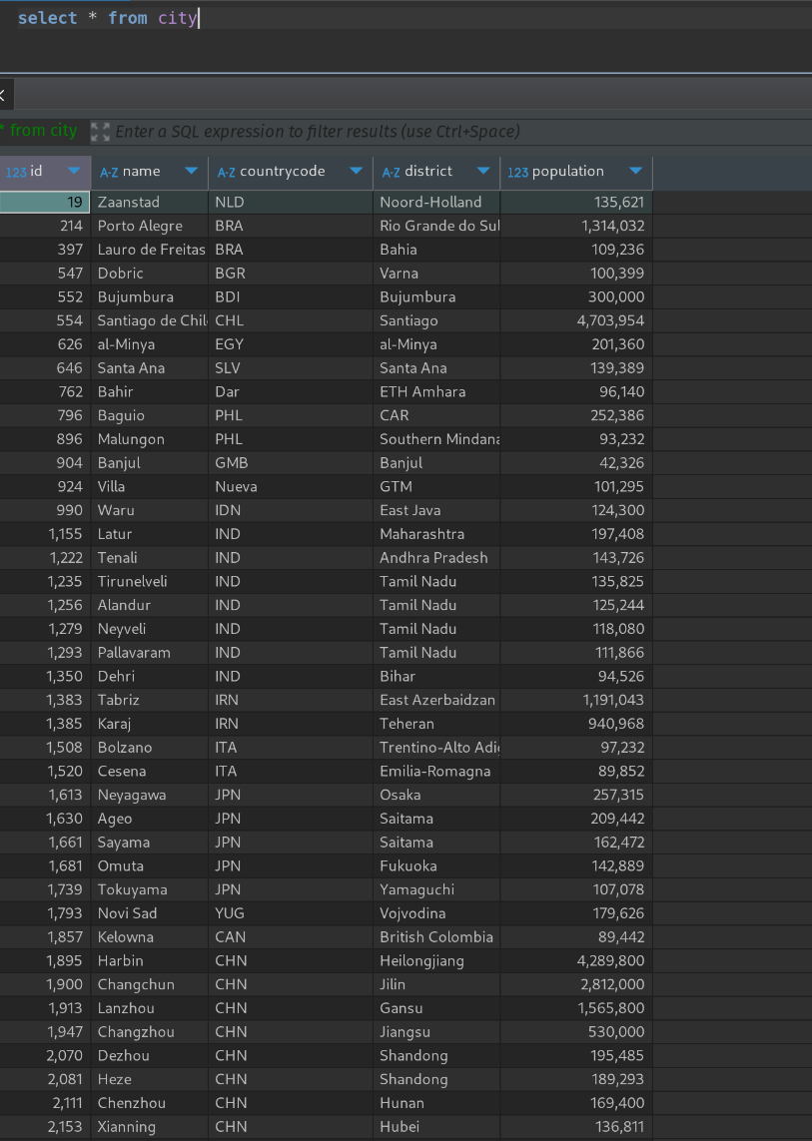
Q3.

Q4.

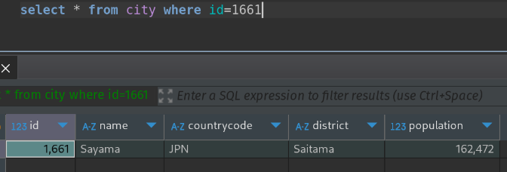
Q5.

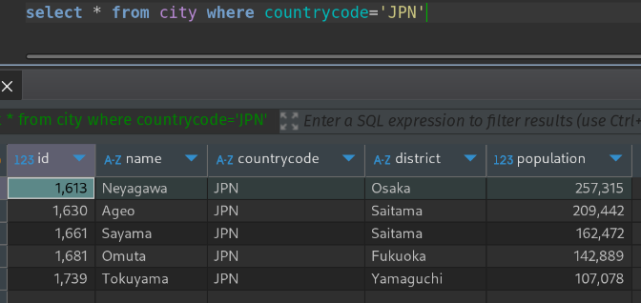
Q6.

Note: Table creation queries for the questions after this were not provided. Therefore, only the queries to perform necessary operation is given

Q7.

SELECT city,state FROM station

Q8.

SELECT DISTINCT city FROM station where id%2=0

Q9.
SELECT (COUNT(city) – COUNT(DISTINCT city)) FROM station

Q10.
(SELECT CITY, LENGTH(CITY) AS length
FROM station
ORDER BY LENGTH(CITY) ASC, CITY ASC
LIMIT 1)
UNION
(SELECT CITY, LENGTH(CITY) AS length
FROM station
ORDER BY LENGTH(CITY) DESC, CITY ASC
LIMIT 1);

Q11.
SELECT DISTINCT CITY
FROM station
WHERE CITY REGEXP '^[aeiouAEIOU]';

Q12.
SELECT DISTINCT CITY
FROM station
WHERE CITY REGEXP '.*[aeiouAEIOU]$';

Q13.
SELECT DISTINCT CITY
FROM station
WHERE CITY REGEXP '^[aeiouAEIOU]';

Q14.
SELECT DISTINCT CITY
FROM station
WHERE CITY REGEXP '^[^aeiouAEIOU]';

Q15.
SELECT DISTINCT CITY
FROM station
WHERE CITY NOT REGEXP '^[aeiouAEIOU]'
OR CITY NOT REGEXP '[aeiouAEIOU]$';

Q16.
SELECT DISTINCT CITY
FROM station
WHERE CITY NOT REGEXP '^[aeiouAEIOU]'
AND CITY NOT REGEXP '[aeiouAEIOU]$';

Q17.
SELECT * FROM product INNER JOIN sales ON product.id=sales.id where sales.sale_data BETWEEN ‘2019-01-01’ AND ‘2019-03-31’;

Q18.
SELECT id from views WHERE author_id=viewer_id ORDER BY asc;

Q19.
SELECT
(SUM(CASE WHEN order_date = customer_pref_delivery_date THEN 1 ELSE 0 END) * 100.0 / COUNT(*)) AS immediate_percentage
FROM
delivery;

Q20.

Q21.
Q22.
Q23.
Q24.
Q25.
Q26.
Q27.
Q28.
Q29.
Q30.
Q31.
Q32.
Q33.
Q34.
Q35.
Q36.
Q37.
Q38.
Q39.
Q40.
Q41.
Q42.
Q43.
Q44.
Q45.
Q46.
Q47.
Q48.
Q49.
Q50.

